**AWS**

**Screenshots of Dashboards:**

1. **AWS Login Screen with Username:**

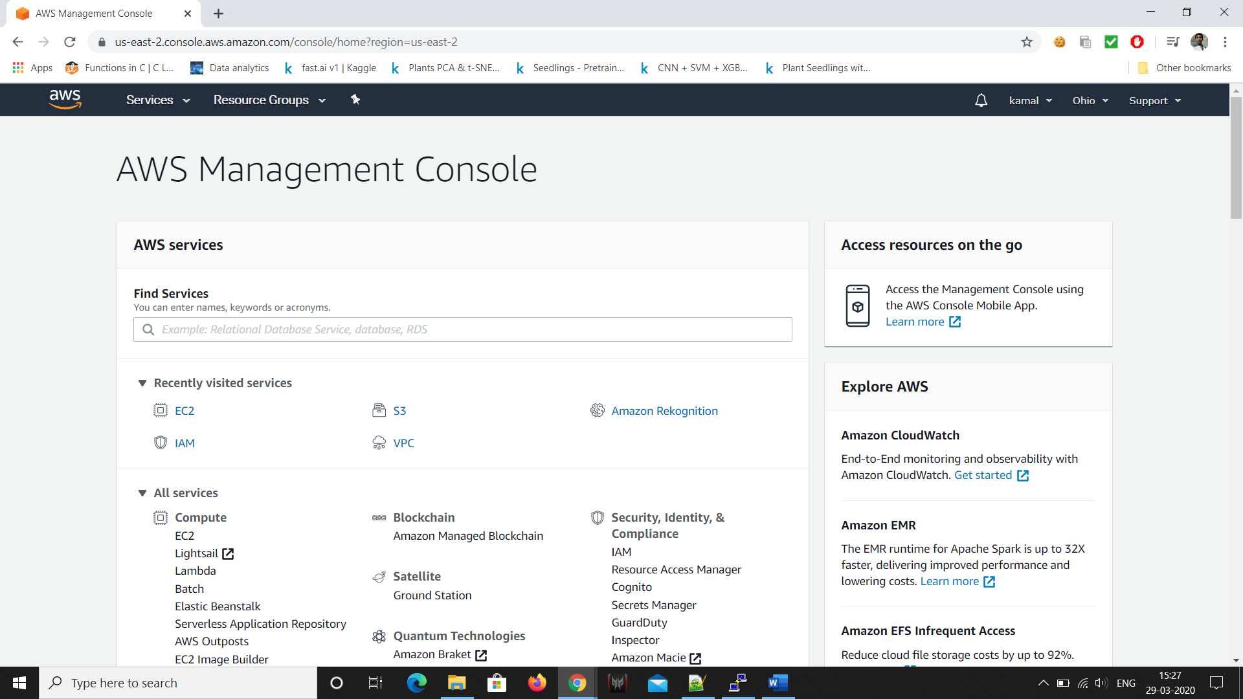

1. **EC2 Dashboard:**

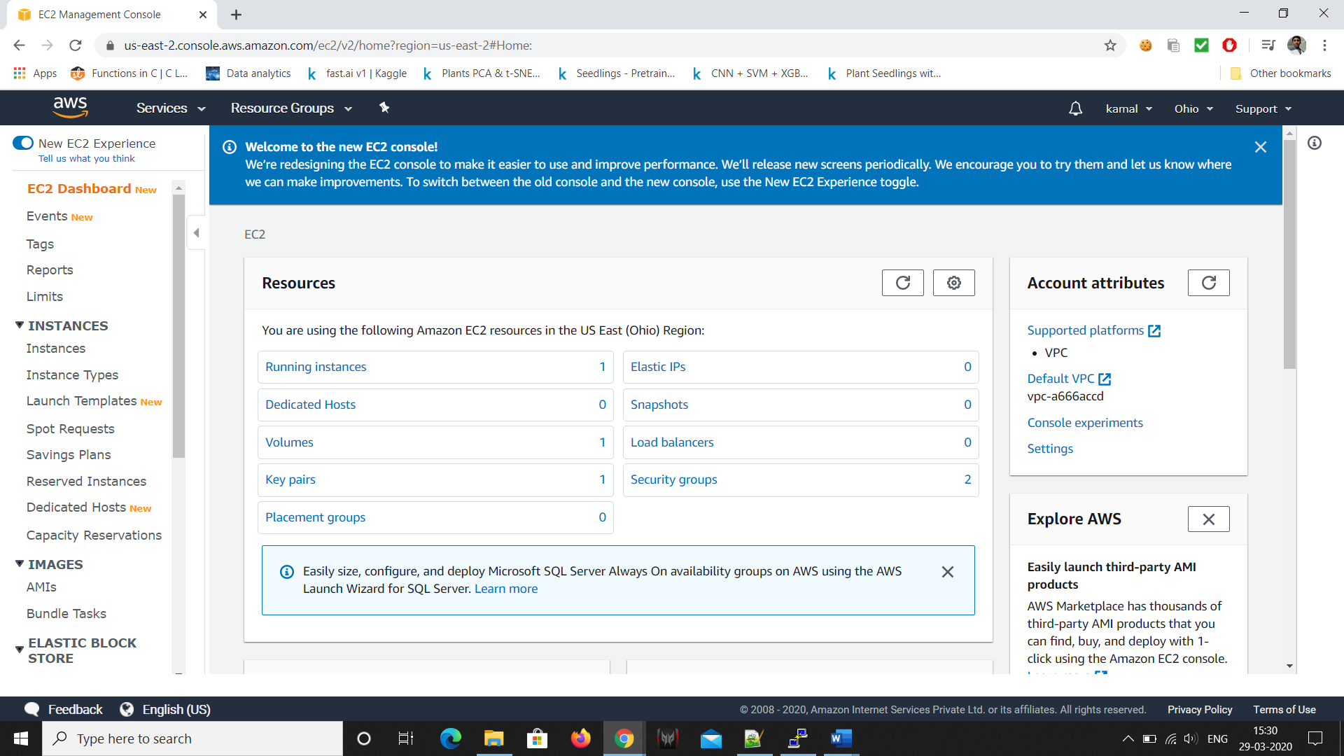

1. **S3 Dashboard:**

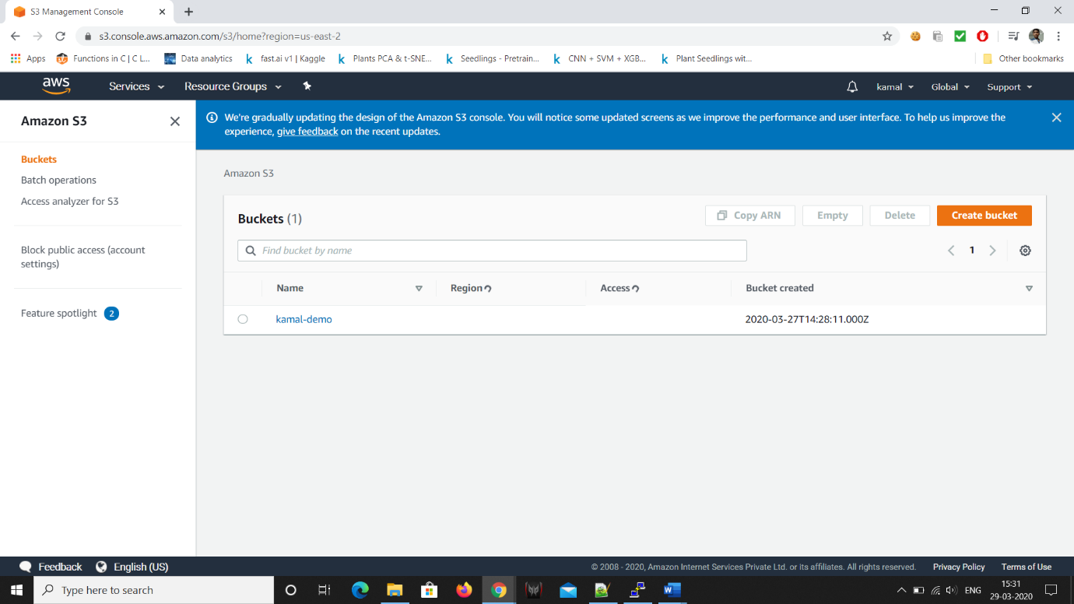

1. **Reckognition Dashboard:**

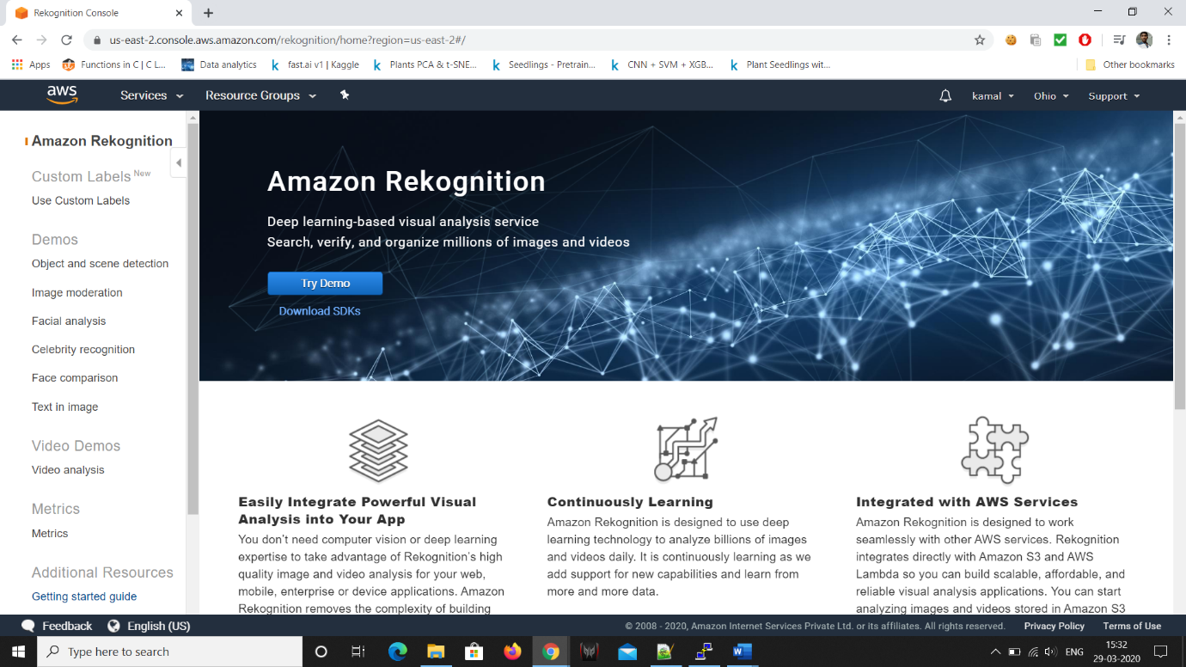

**Screenshots of EC2:**

Create an AWS account and go to EC2 service

Click on launch instance

1. **Choosing an AMI**

And select a operating system with a ram

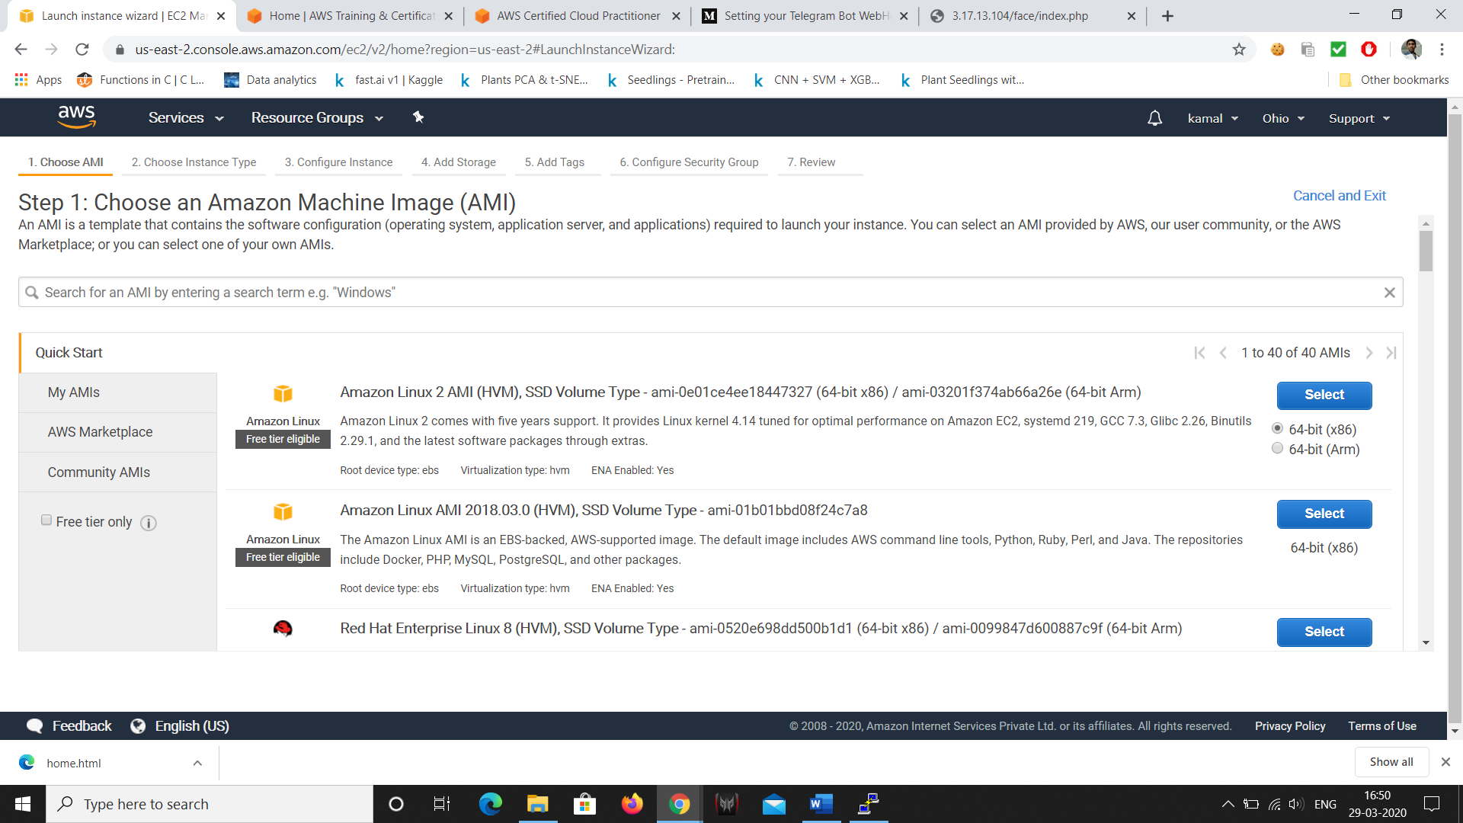

1. **Choosing an Instance Type**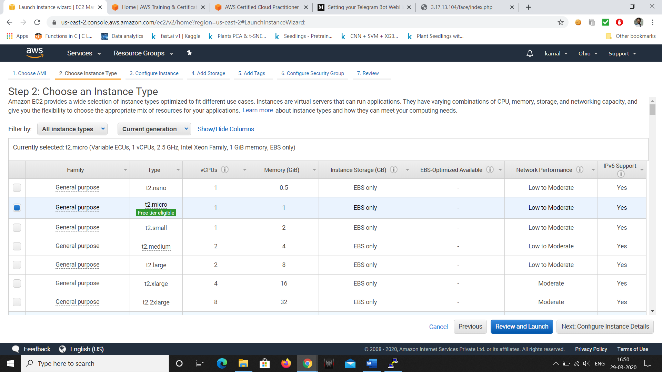

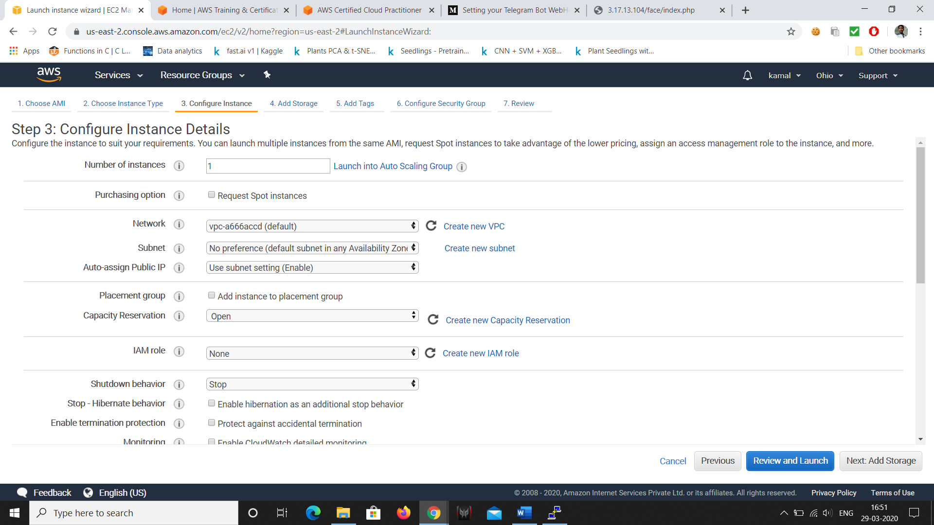

1. **Adding Storage**

Next add storage as your own I selected as 8

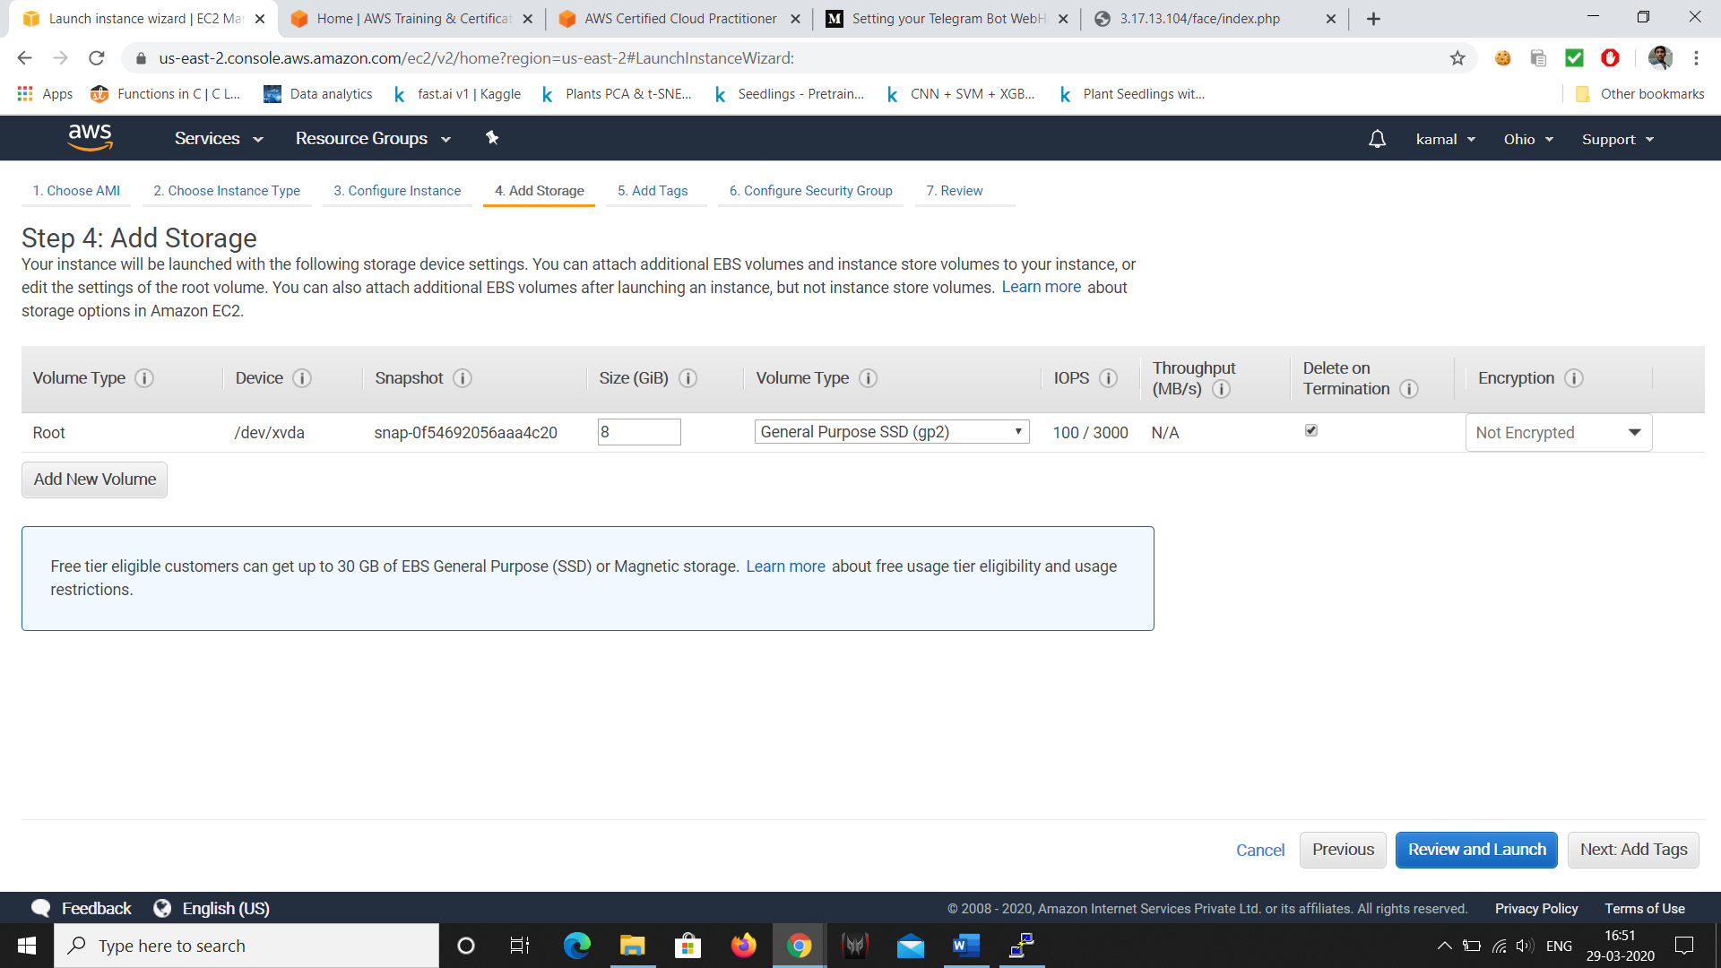

1. **Configuring Security Group**

Check the type is SSH and port number is 22

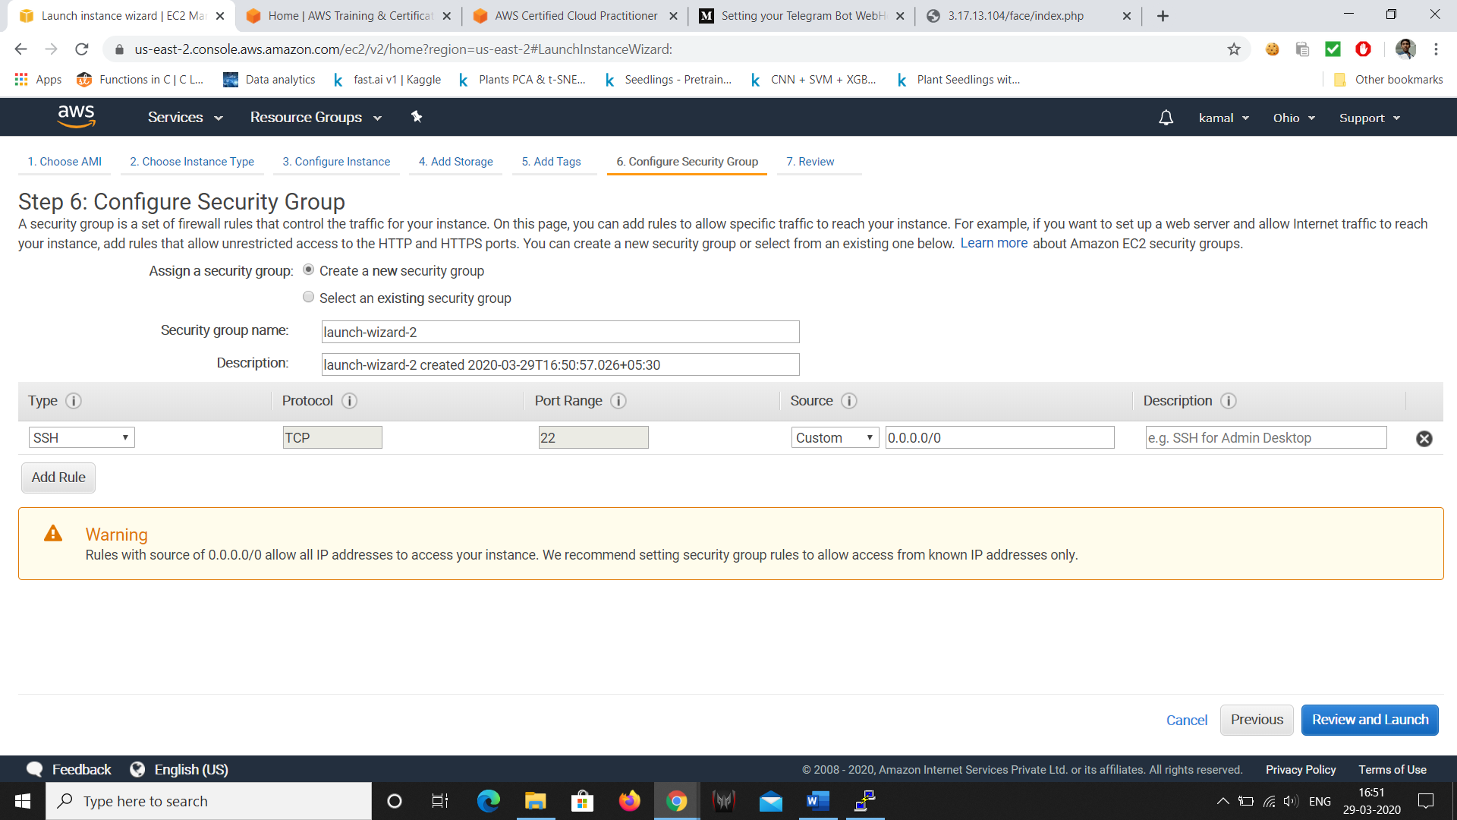

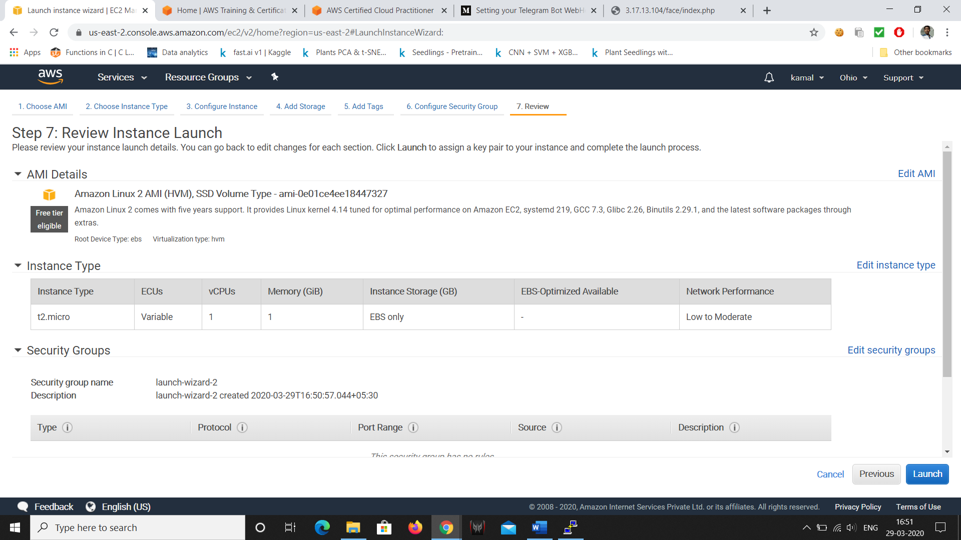

Click on REVIEW and LAUNCH

Review the all the things you entered and click on Launch.

We get a pop up window and choose a create a new key pair

And write the key pair name as your own.

1. **Key Pair Download**

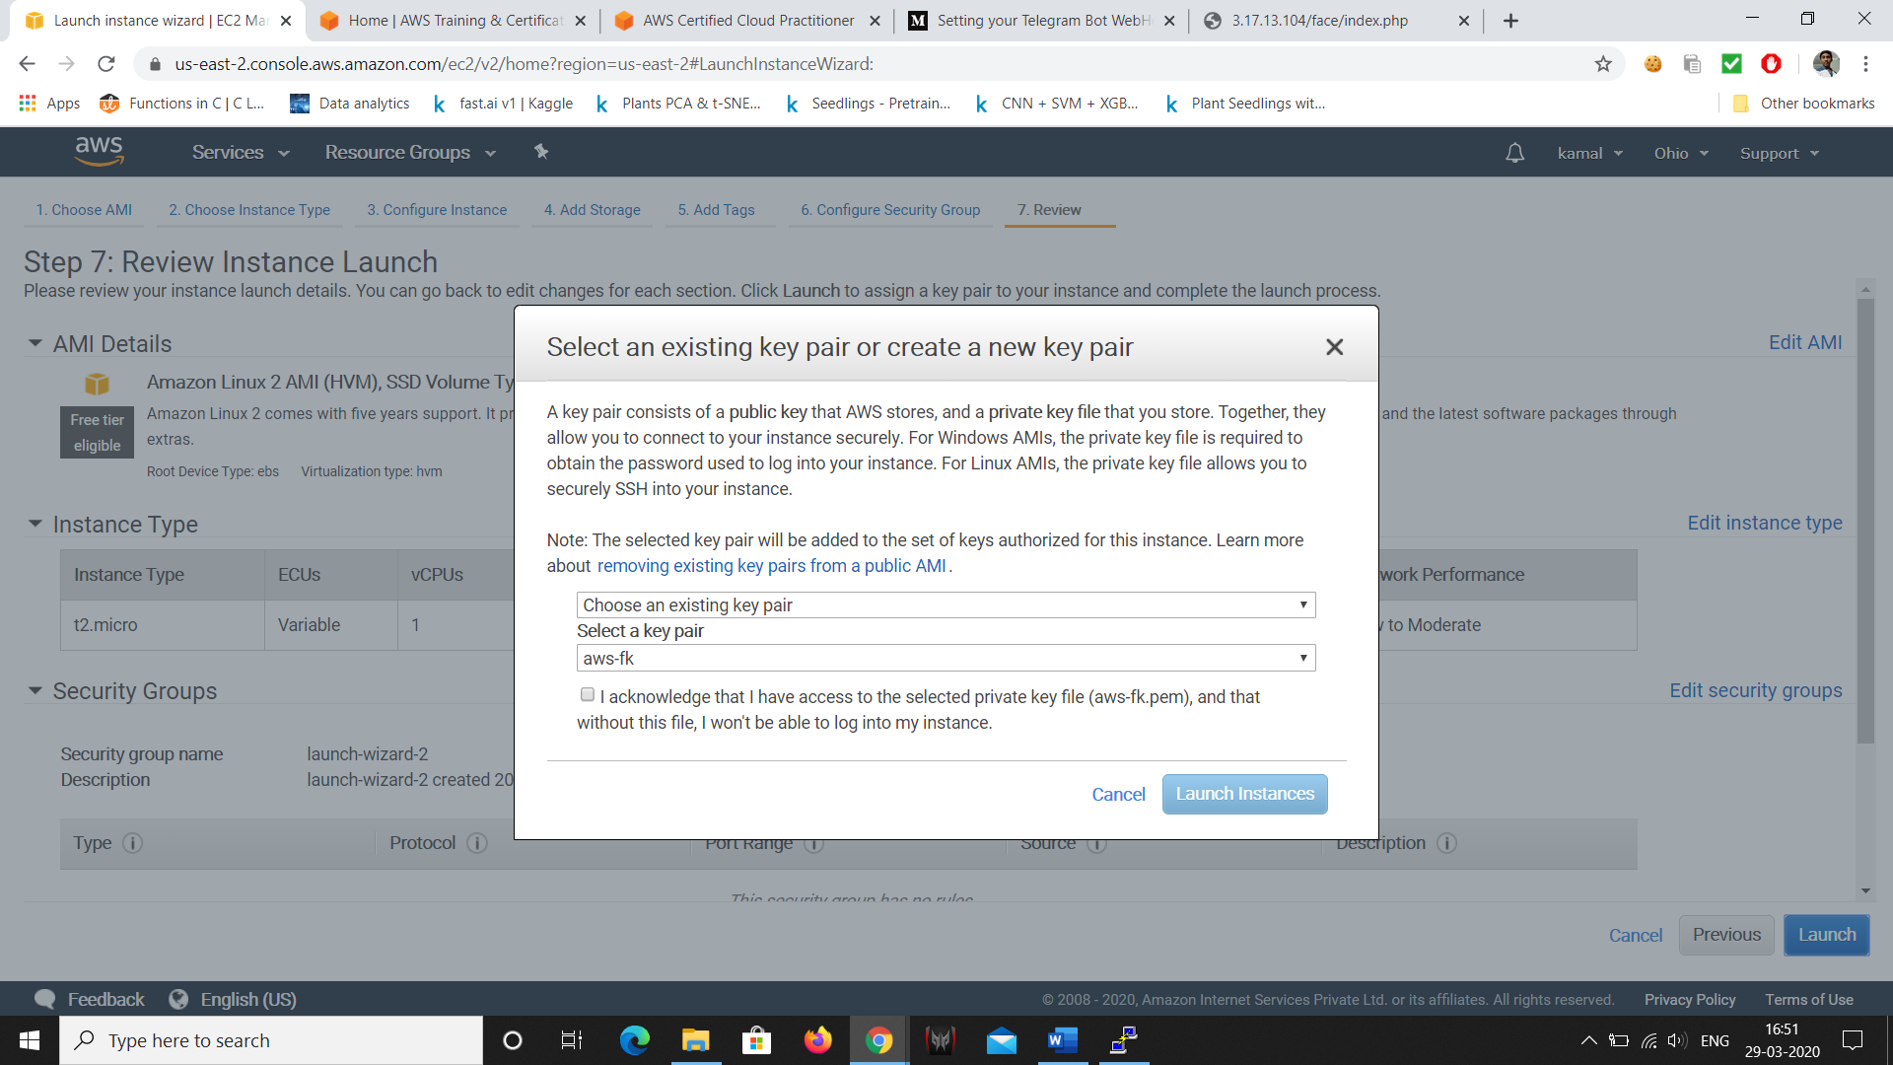

And launch and download a keypair.

After launch click on the link it start your instance.

It is In a format of .pem

getting connected

1. **PuTTYgen conversion from pem to ppk**

Convert pem to ppk -puttygen (or) command we can do

command lie -> pttygen KETFILE.pem -o KEYFILE.ppk

it will convert the .pem to .ppk

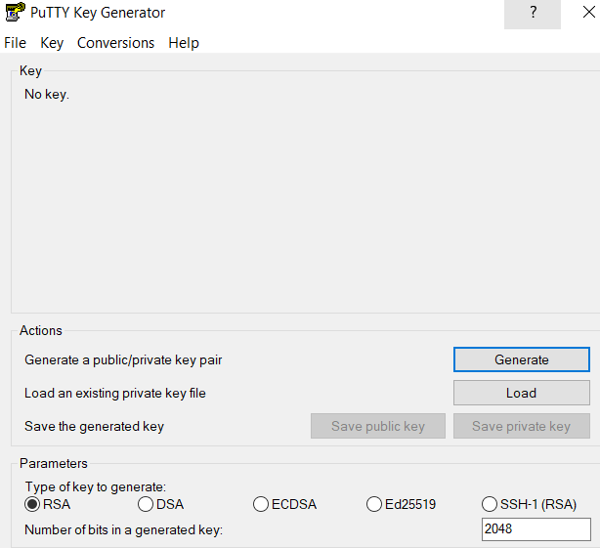

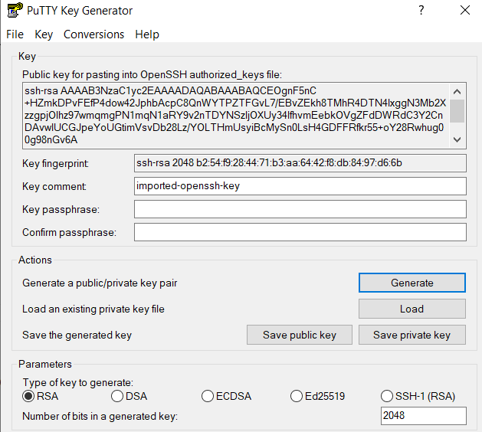

Press on save private key

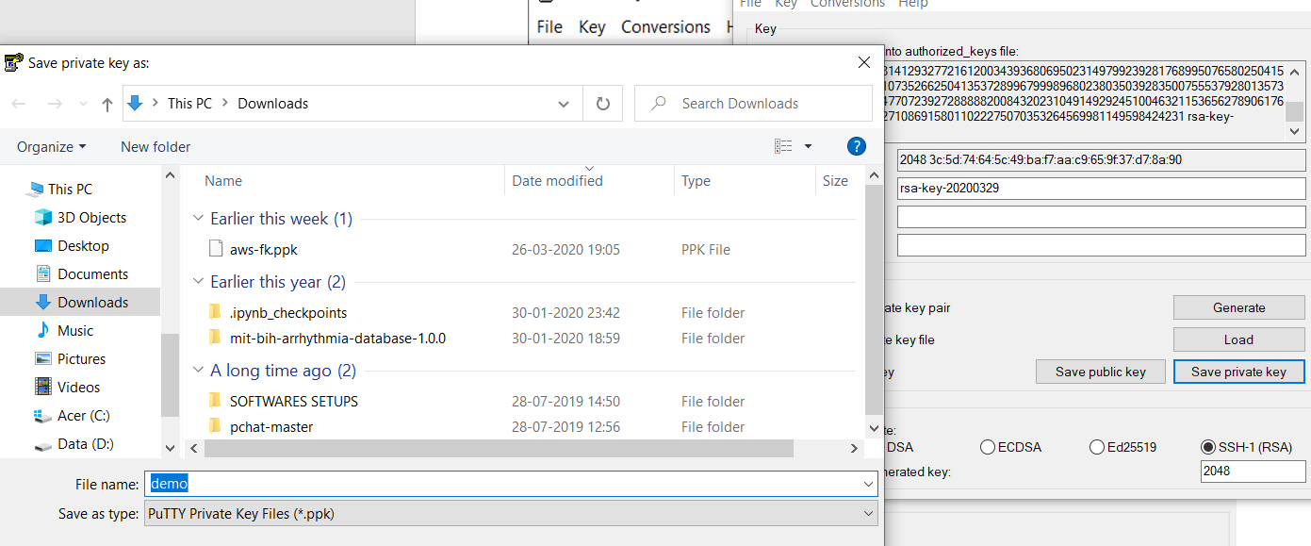

download putty from online

and open putty enter your ip addres in AWS and select SSH and port number as 22

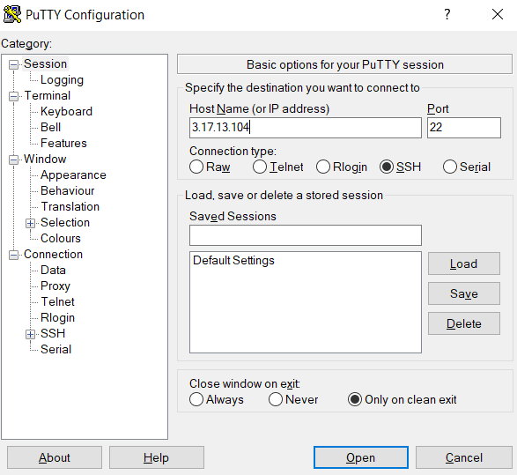

go to connection In left side of the putty expand that and expand SSH click on Auth and browse a keypair of format .ppk

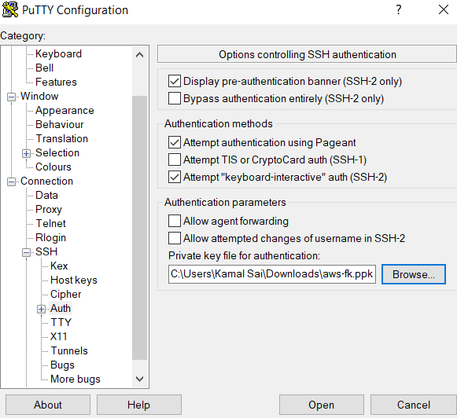

And open

1. **Logged in EC2 black screen**

Login as ec2-user

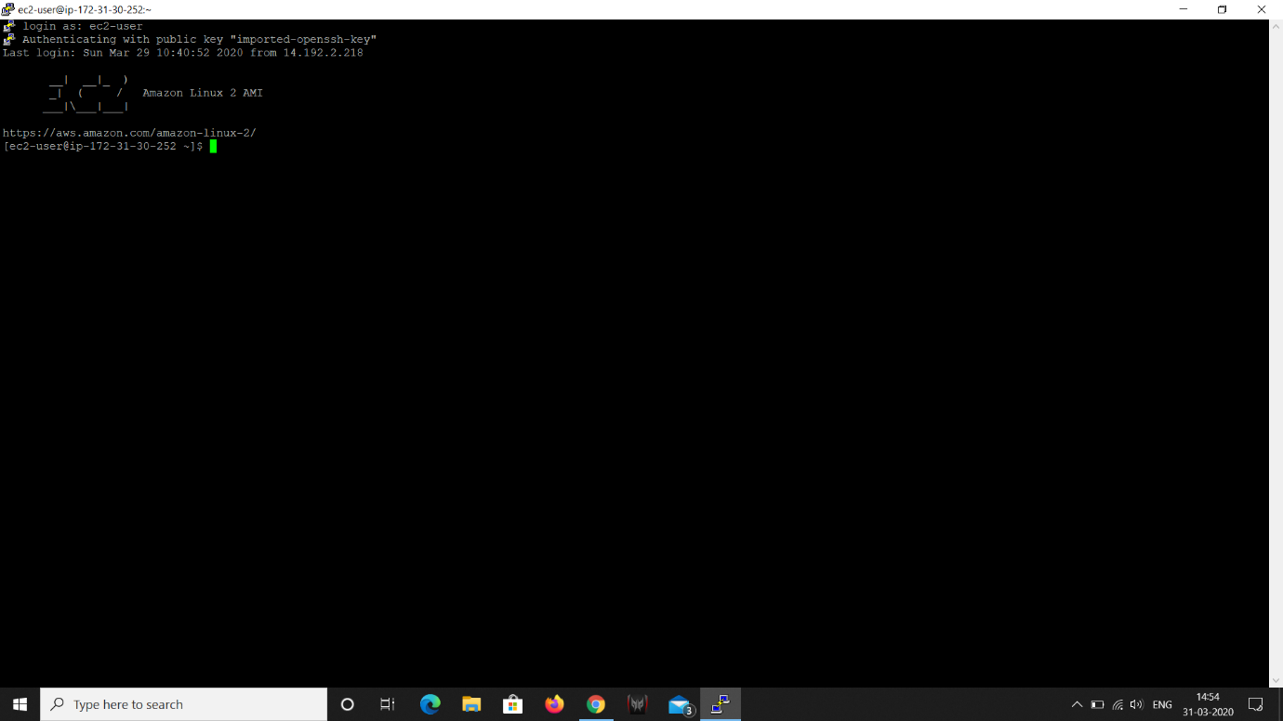





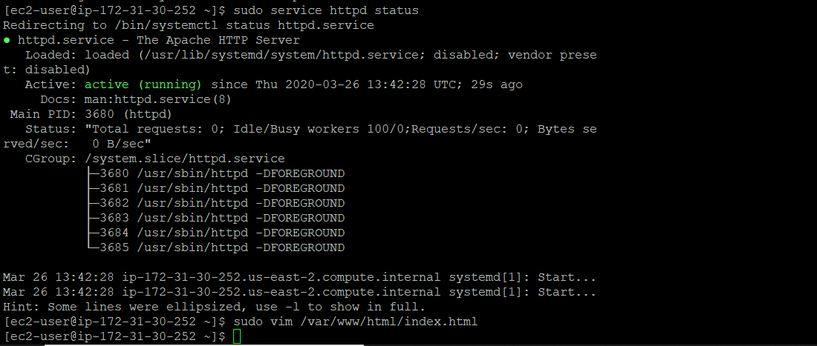

Press i we get into

And we can write what ever we want

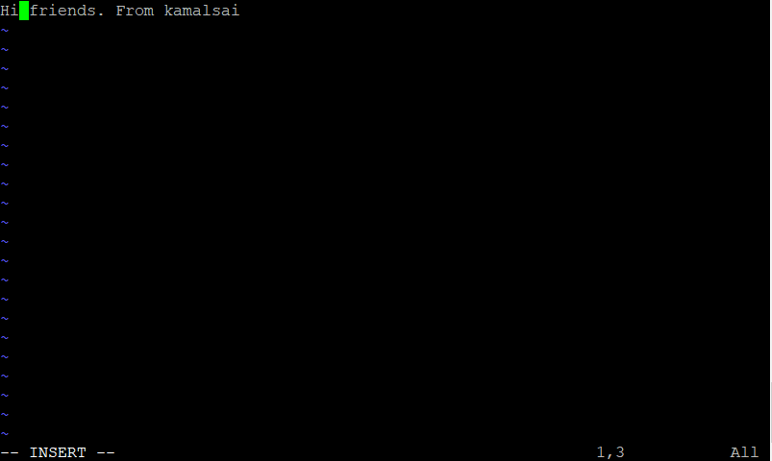

ESC :wq (hit an enter)

We get back to back normal console

Open browser and enter your ip address of your which is present in aws

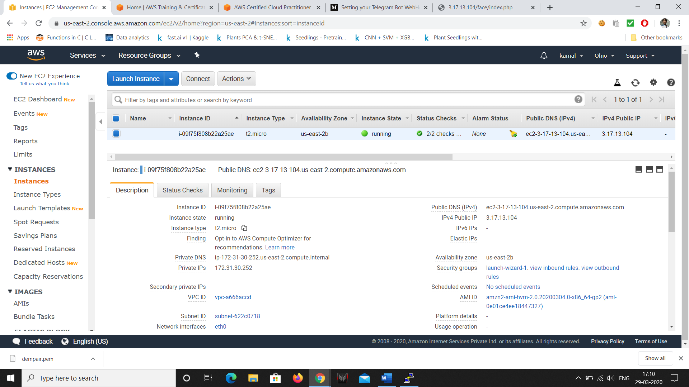

If it not show then go to aws and in Security group click on [launch-wizard-1](https://us-east-2.console.aws.amazon.com/ec2/v2/home?region=us-east-2#SecurityGroups:groupId=sg-075169993a8375ed9;sort=groupId)

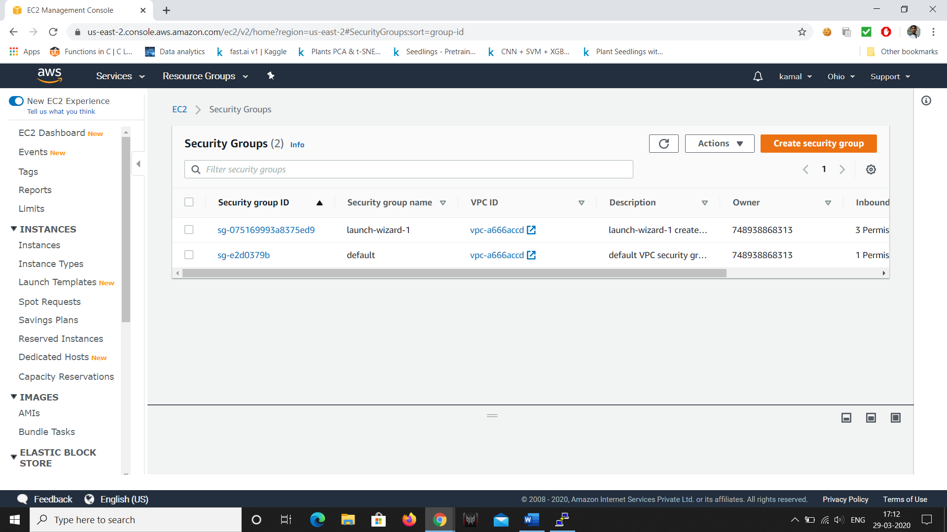

Click on security group id and edit inbound rules and add rule and set it to http and make source to anywhere and save rule.

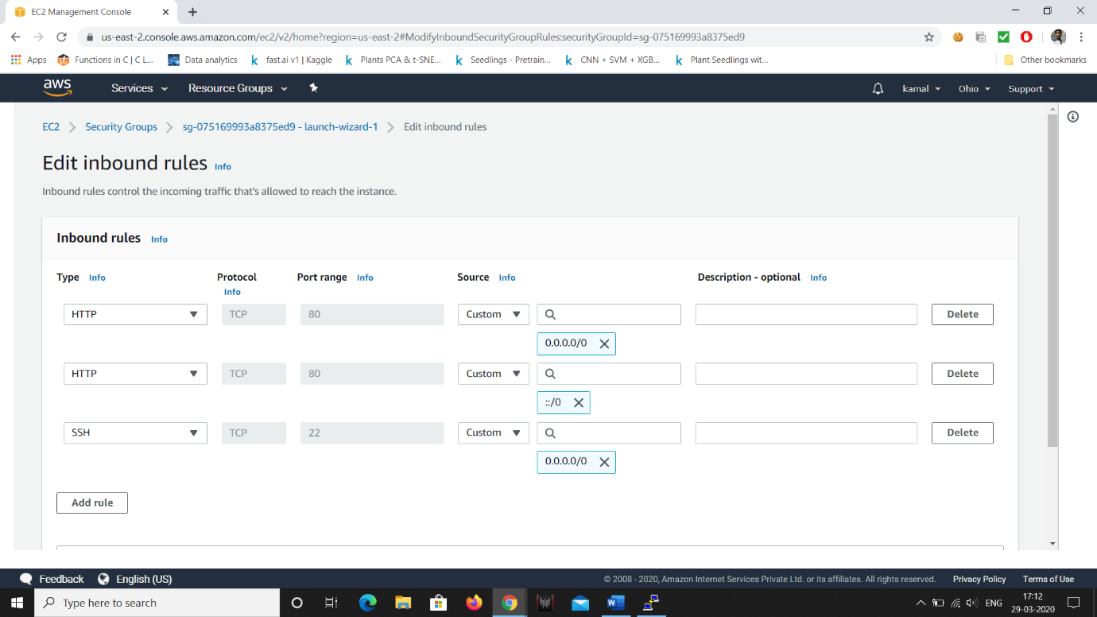

Now open browser and search your ip address it will show what you typed message before.

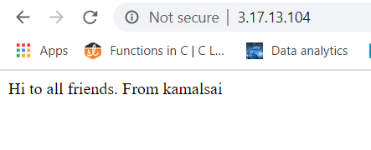

**Screenshots of S3:**

1. **Creating a bucket**

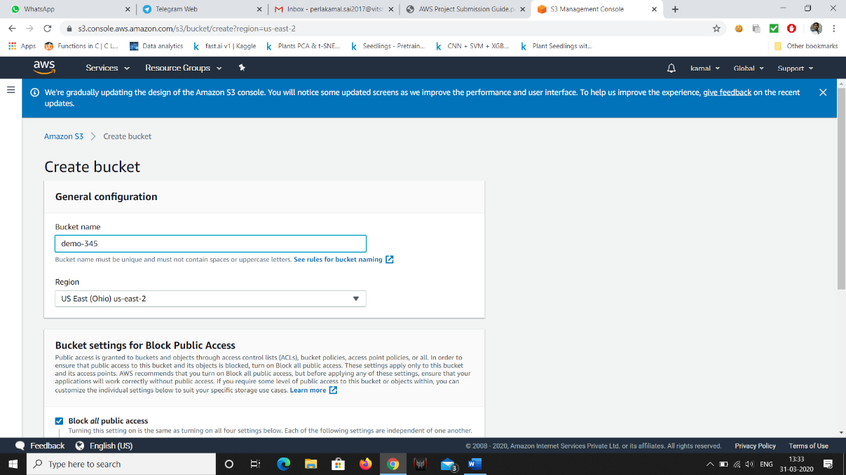

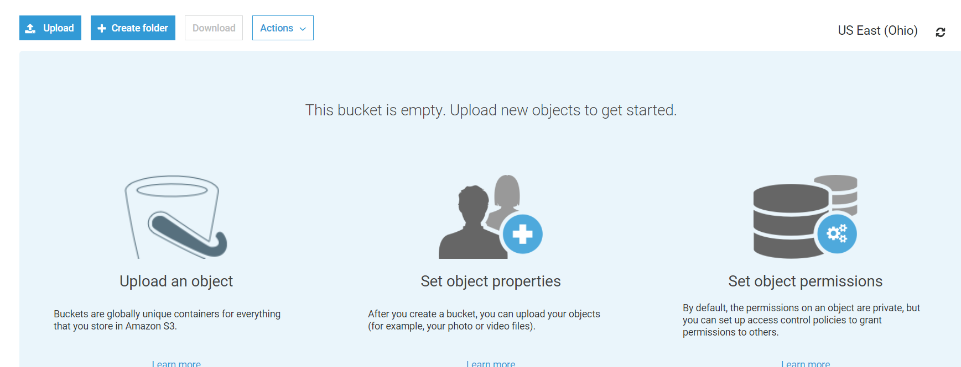

1. **Uploading an Object**

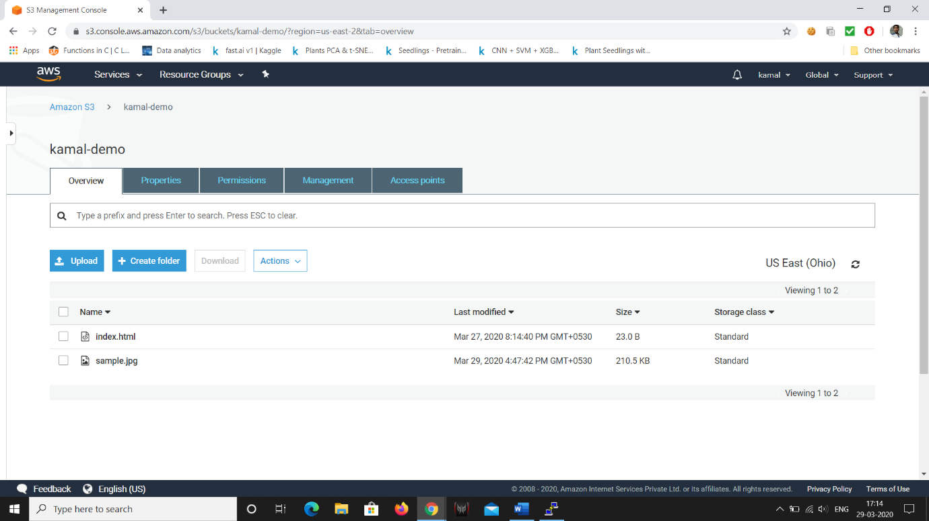

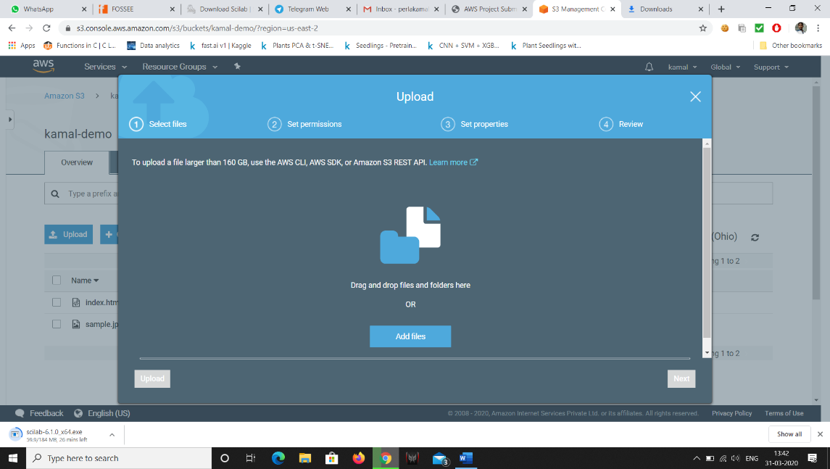

Upload a file

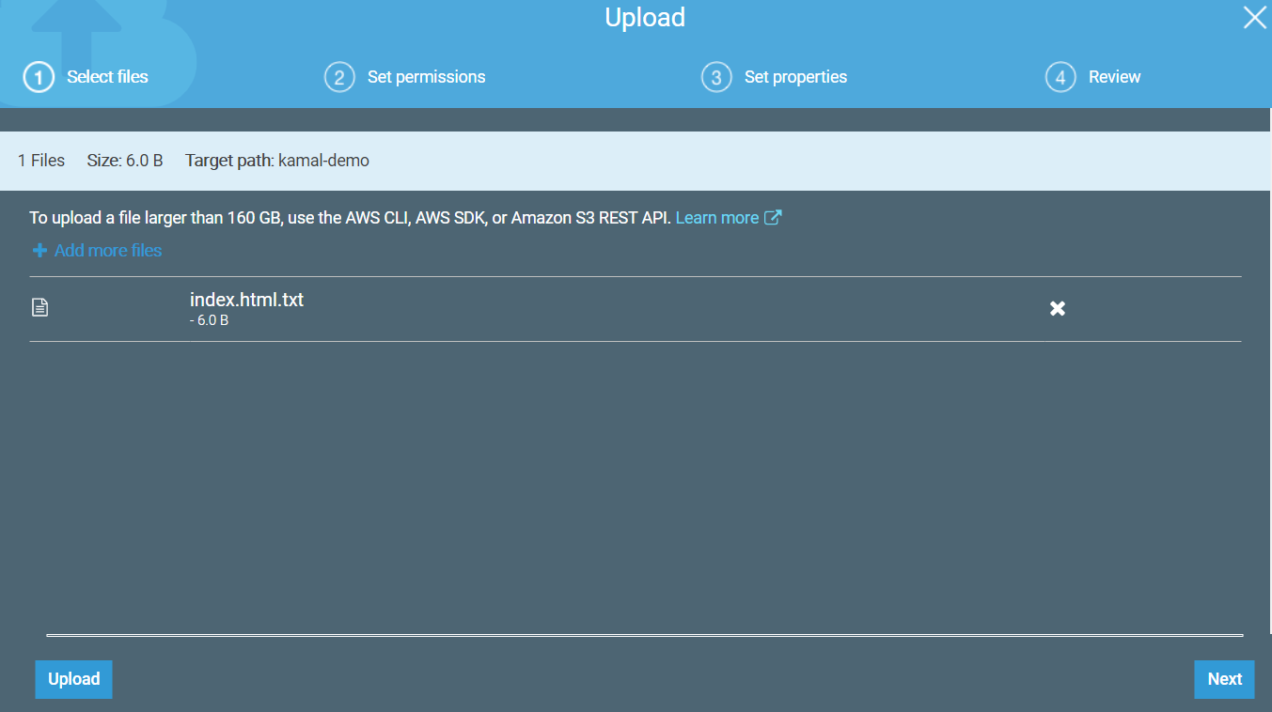

Click on next And make sure that it should be on standard

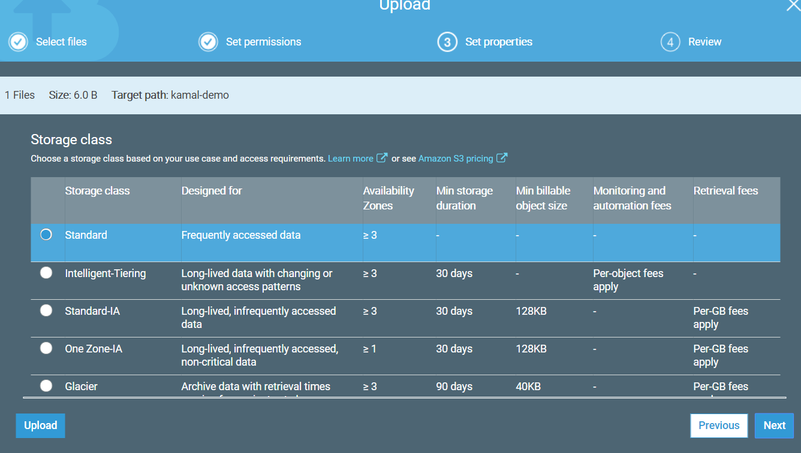

Click next and click upload not change anything

The uploaded file looks like



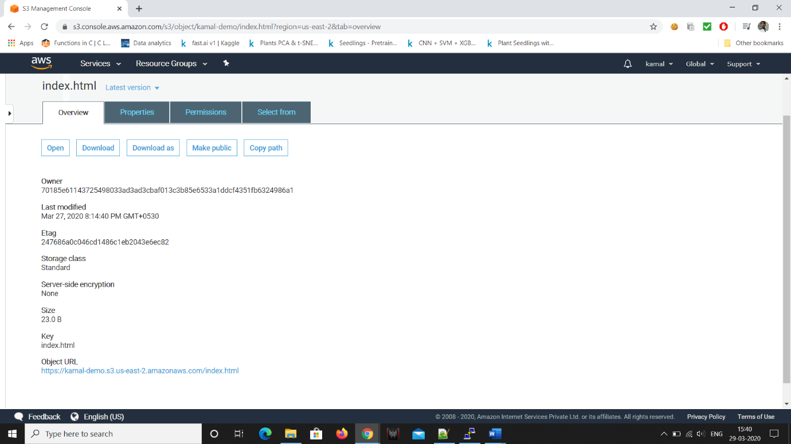

Press make public.

1. **Enabling Static Website**

Go to properties

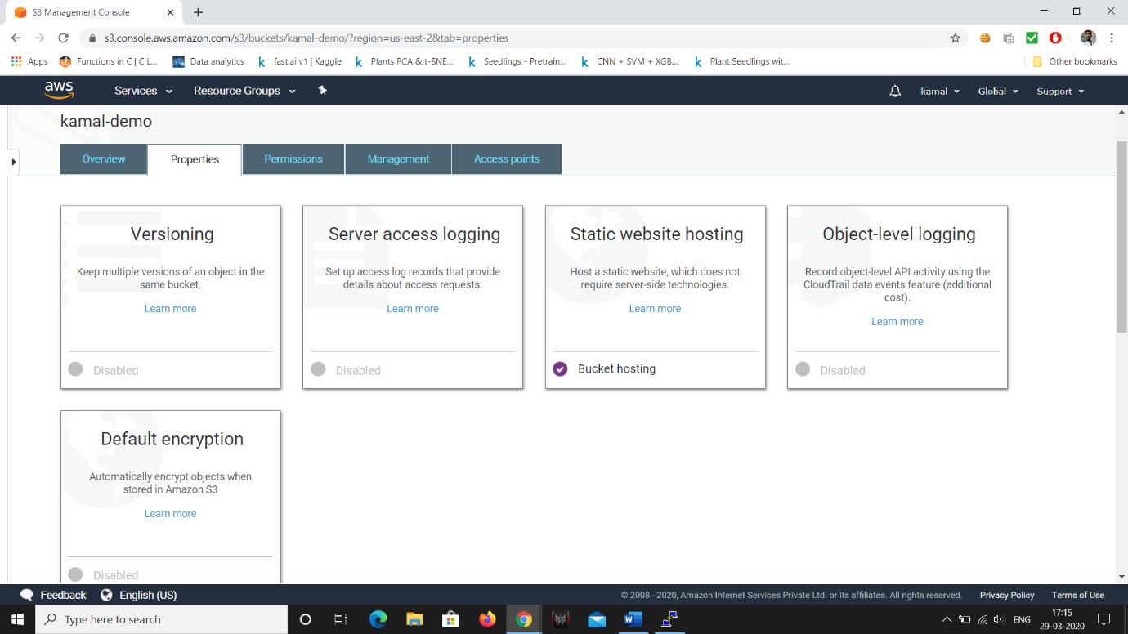

Click on Static website

And go to bucket to host a website and save

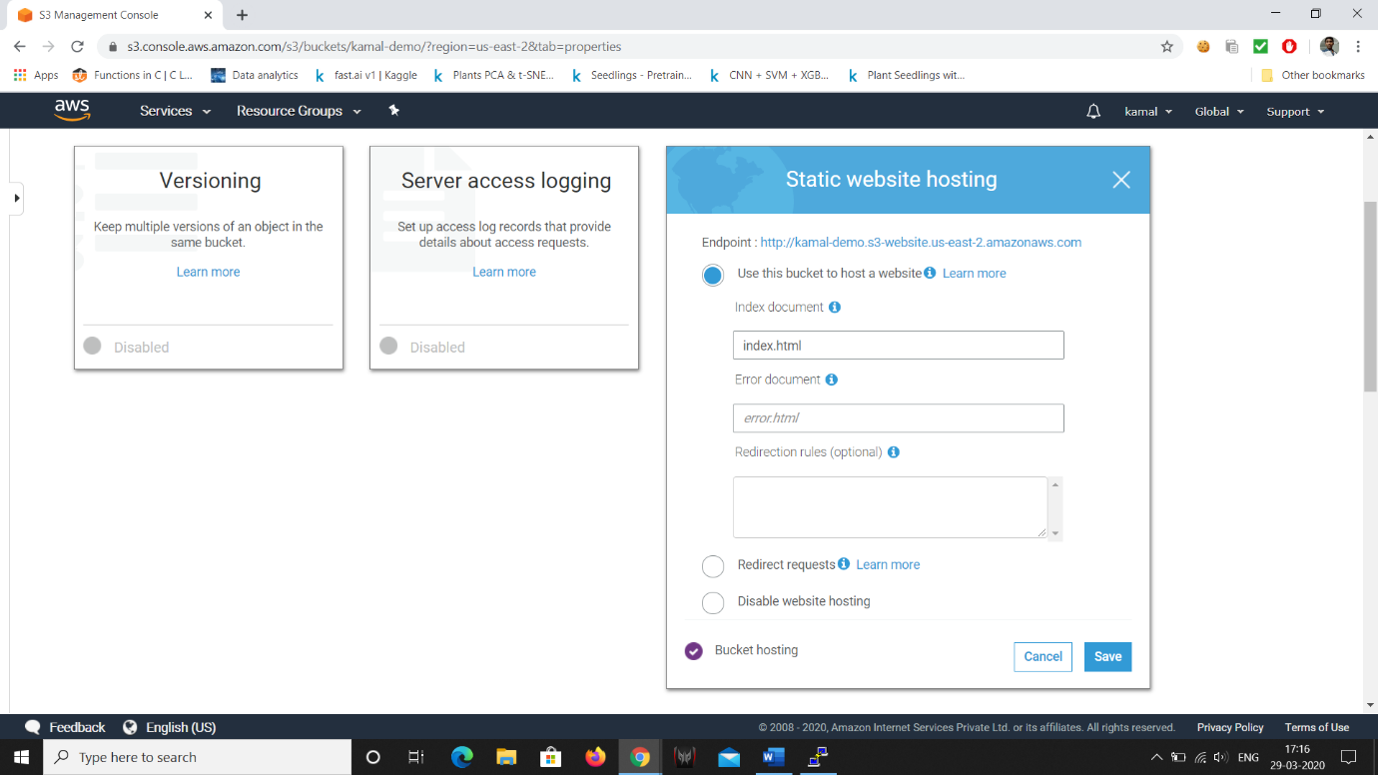

1. **Making the Object Public**

Go to permissions and click on edit

Off the block all public access

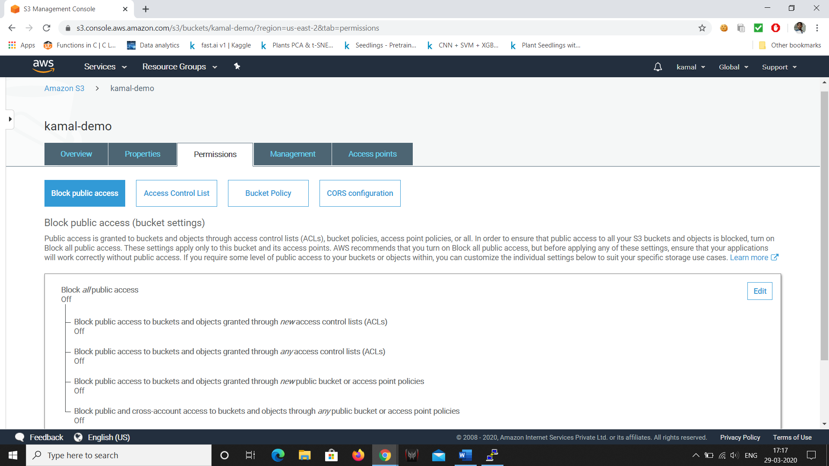

Go to overview and click on object and click on make public

1. **Checking the S3 link on the browser**

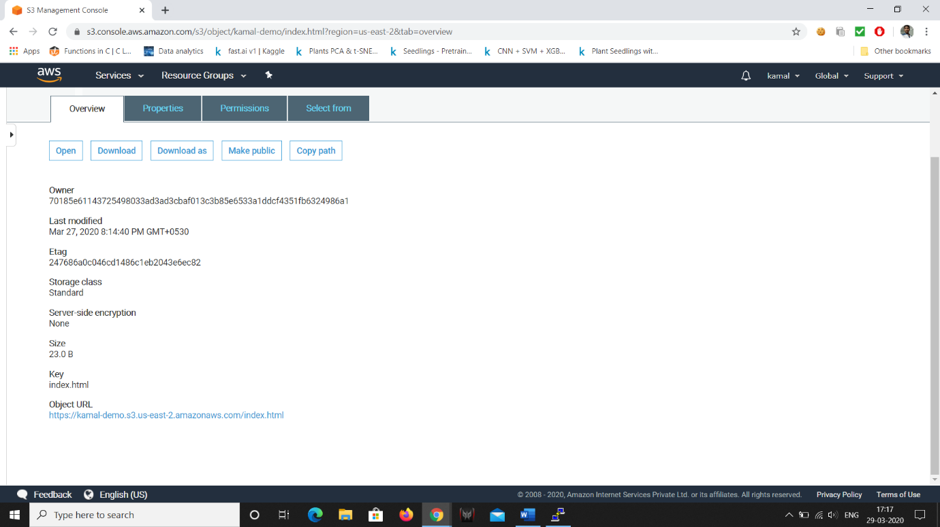

And click on URL at bottom it show the what is there in file.

Or go to properties click on website hosting there you find a enpoint

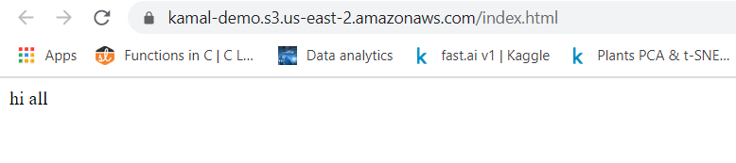

**Screenshots of Rekognition**:

1. **Object and Scene detection**

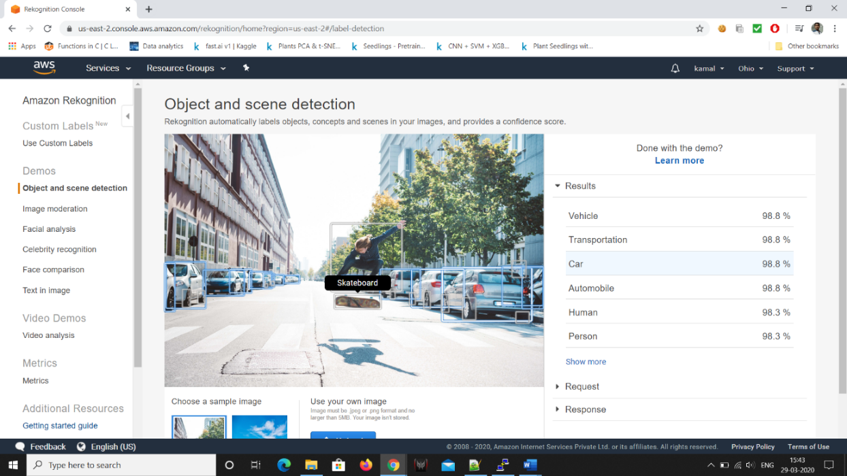

1. **Face Detect**

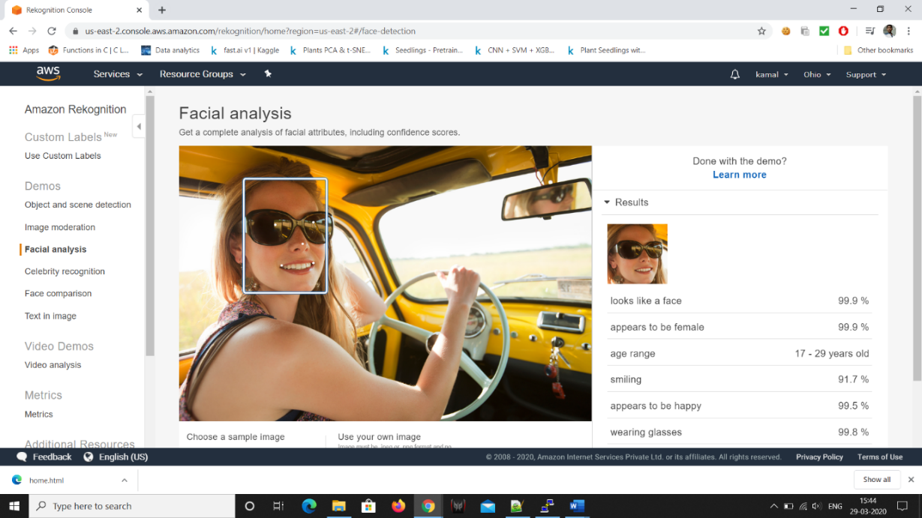

1. **Celebrity Recognition**

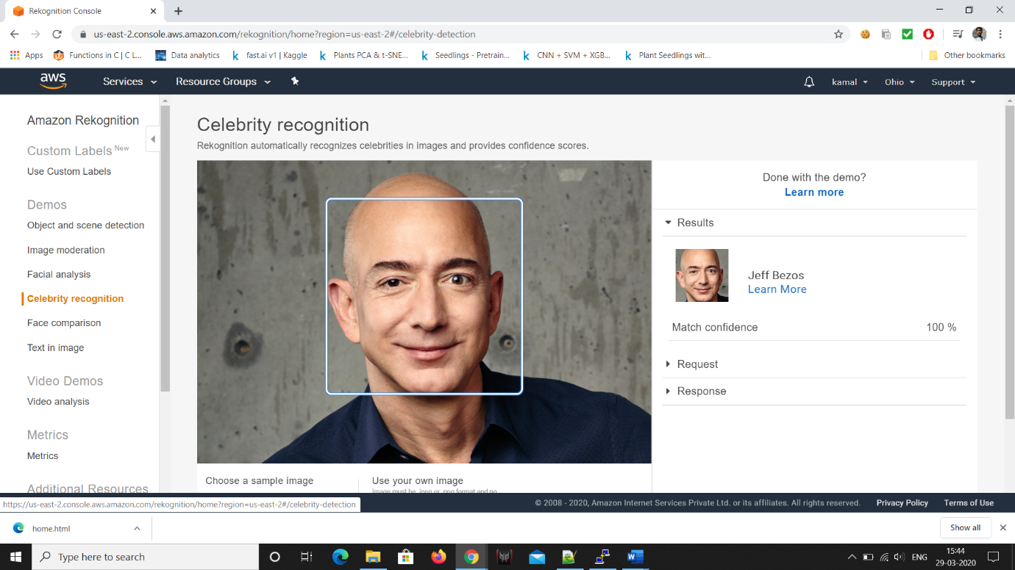

1. **Face Compare**

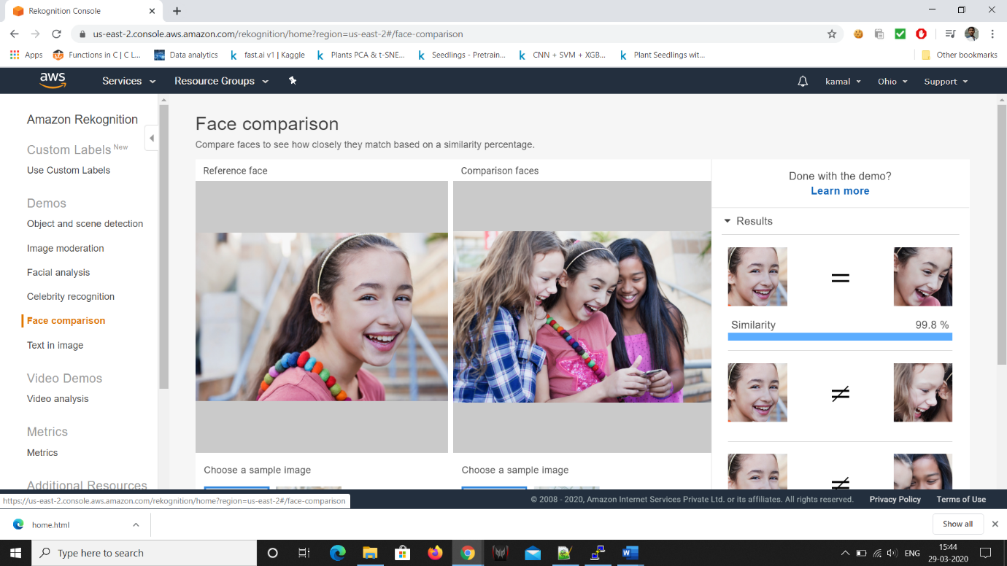

1. **Text in Image**

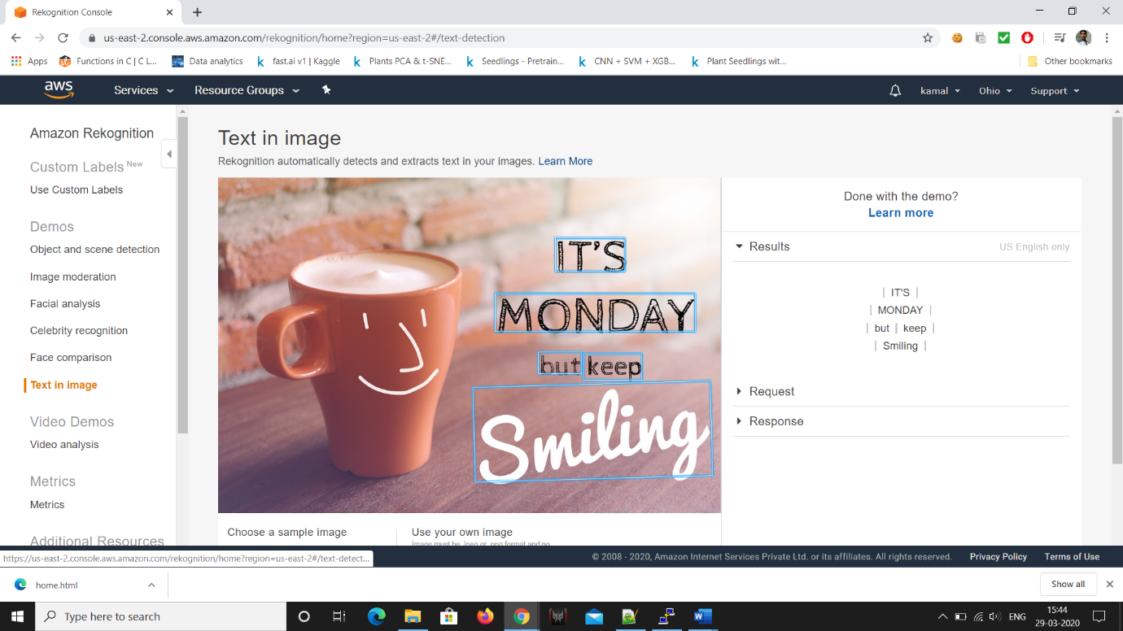

IAM:

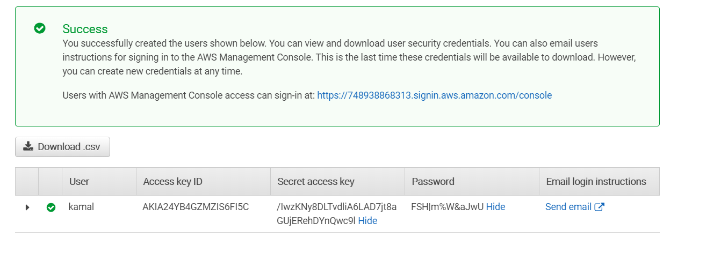

Create a IAM role

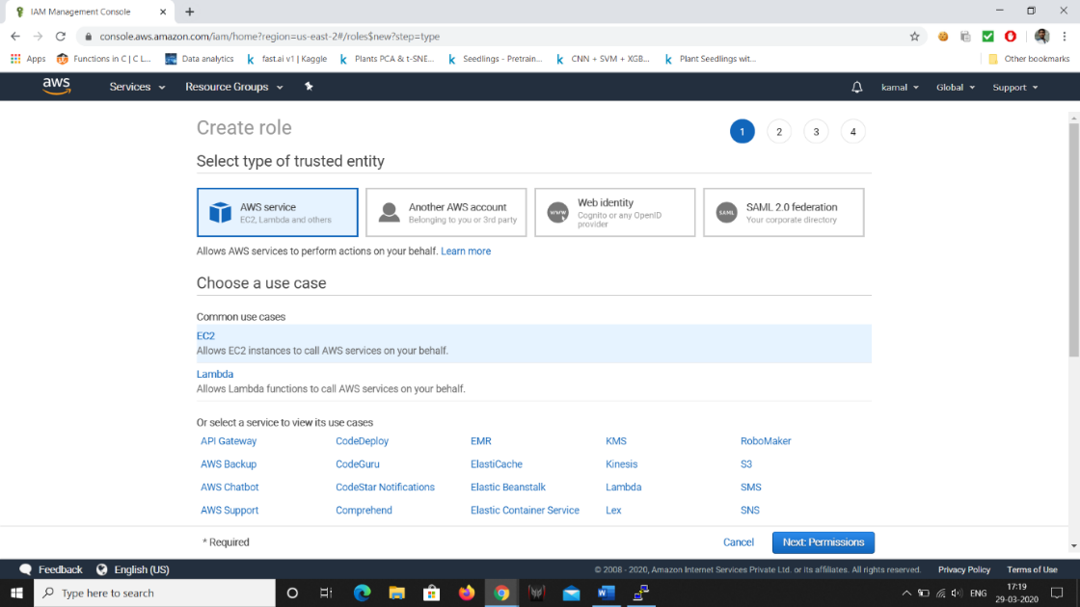

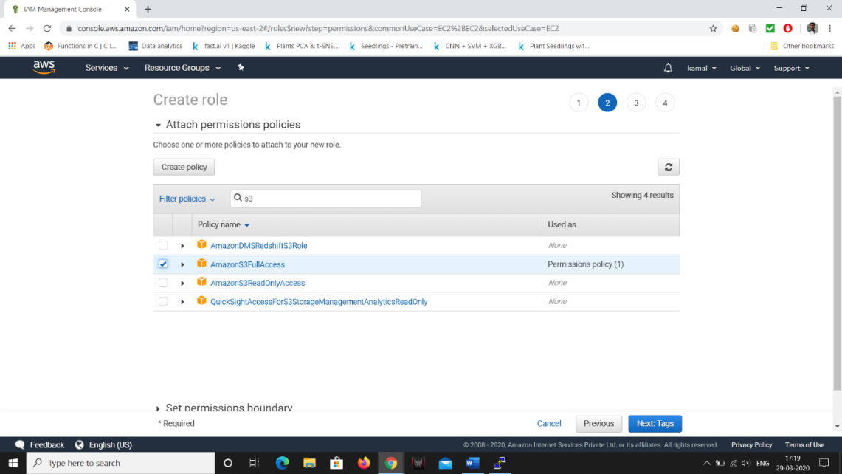

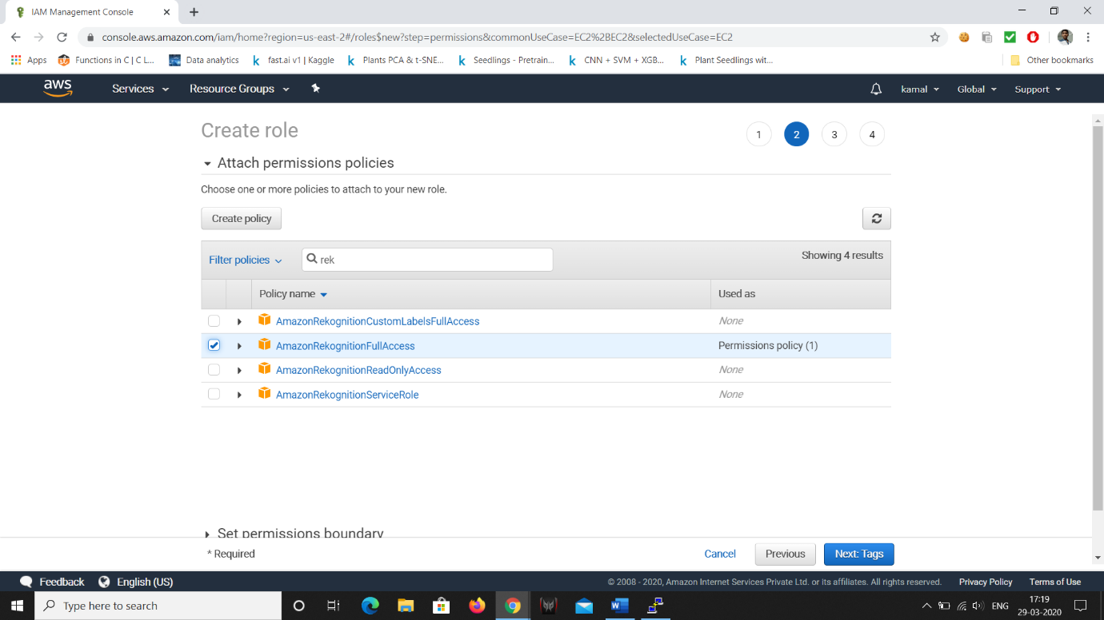

Ignore tags and

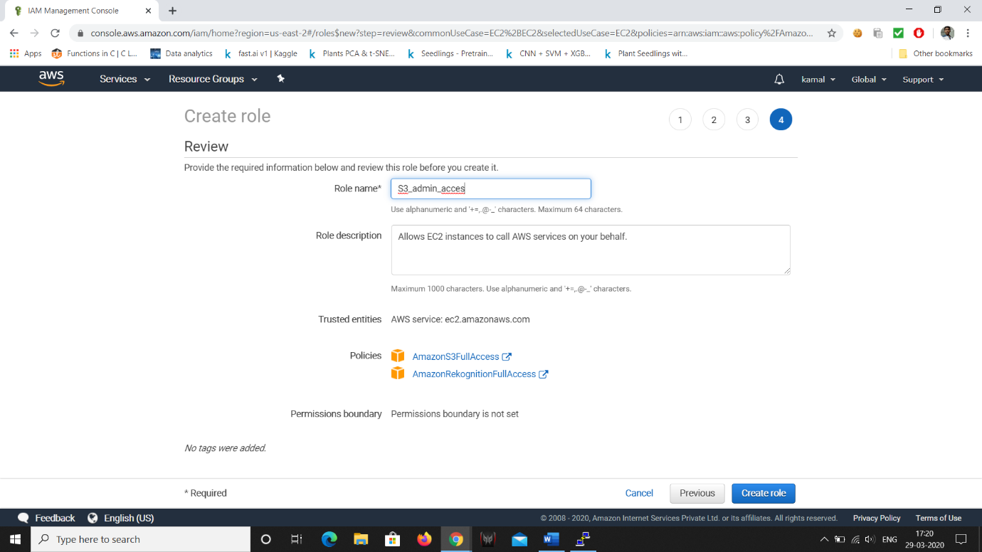

Create role .

Go to EC2 and running instatnce and attach/Replace IAM Role

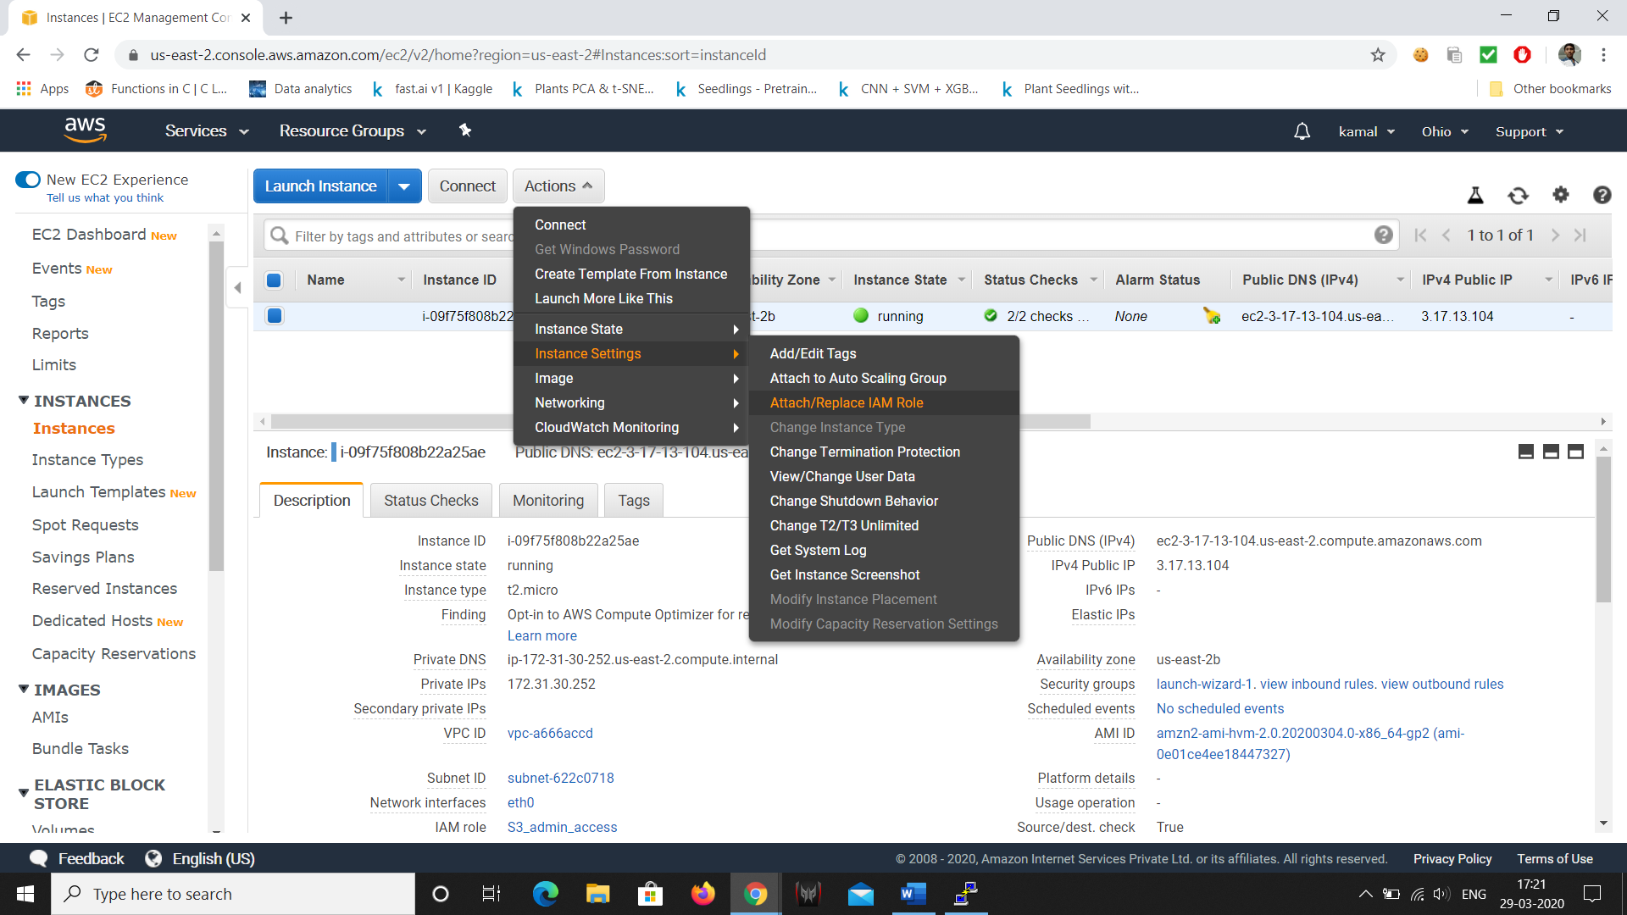

Select the role and press apply

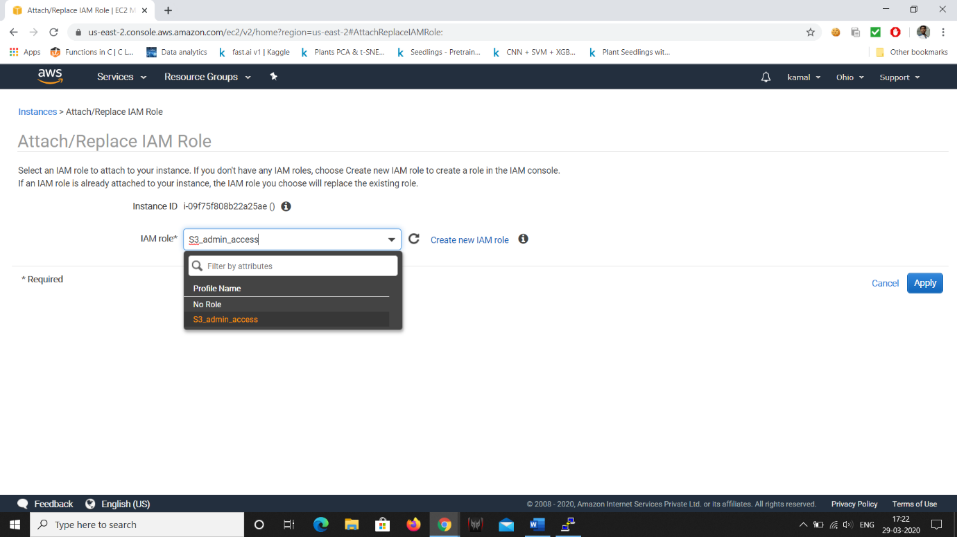

**Screenshots needed for EC2 & S3:**

1. **Installing aws-sdk**

sudo php -d memory_limit=-1 ~/composer.phar require aws/aws-sdk-php

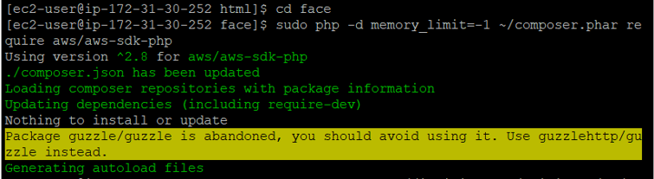

1. **Installing php**

sudo yum install php

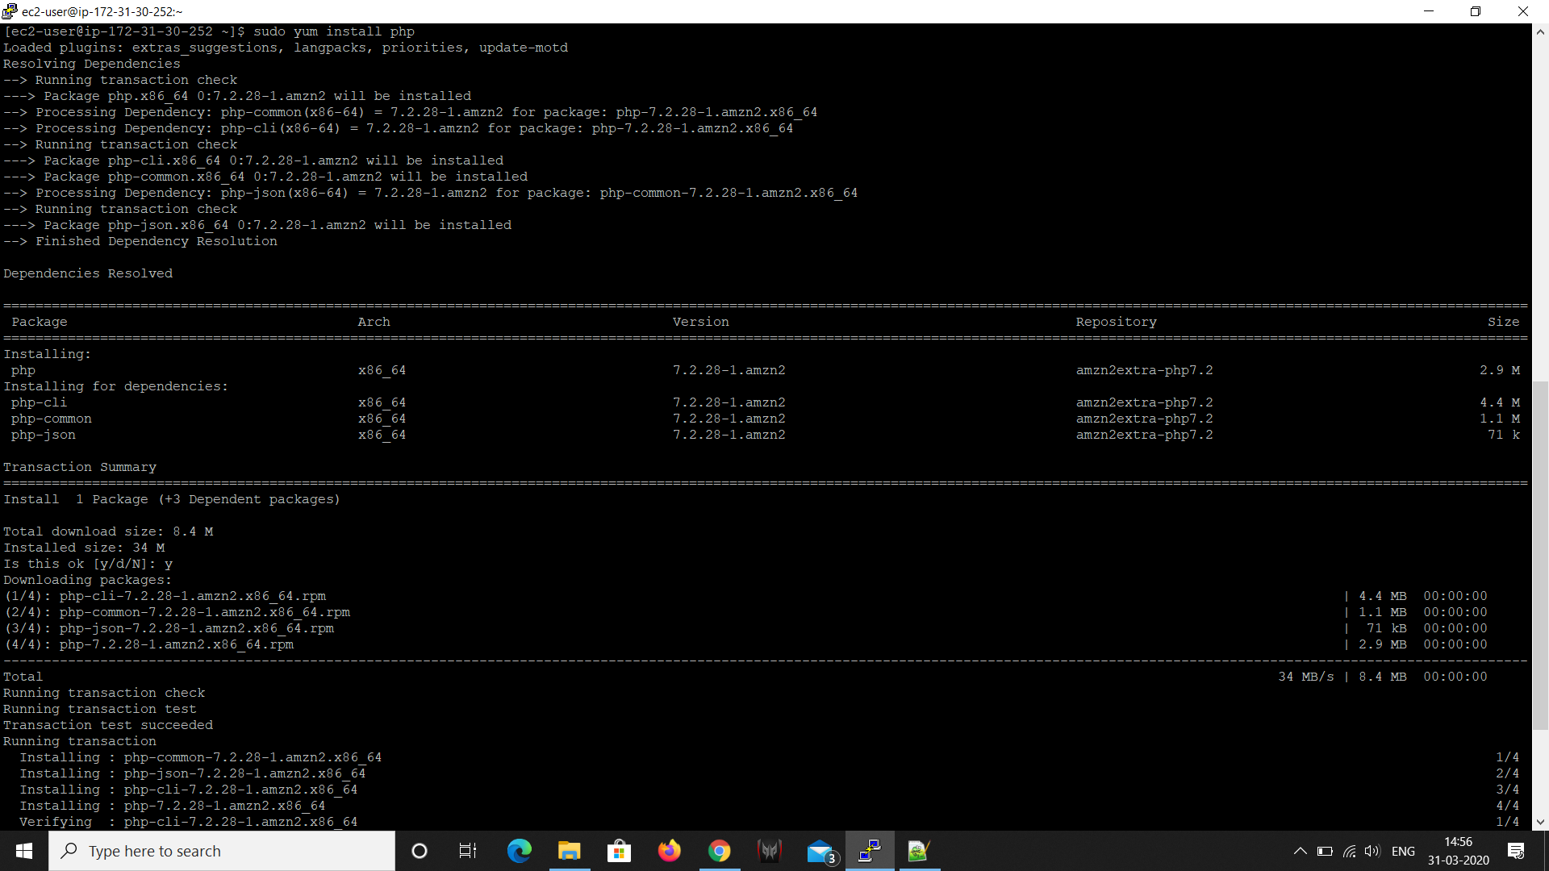

1. **index.php file code**

<?php

/*

Install php - sudo yum install php

curl -sS https://getcomposer.org/installer | php

cd /var/www/html

sudo mkdir face

cd face

sudo php -d memory_limit=-1 ~/composer.phar require aws/aws-sdk-php

In case if you get memory error -

sudo /bin/dd if=/dev/zero of=/var/swap.1 bs=1M count=1024

sudo /sbin/mkswap /var/swap.1

sudo /sbin/swapon /var/swap.1

sudo wget https://i.pinimg.com/originals/b9/7e/a3/b97ea33b5842c7894b804923c6c05580.jpg

sudo mv b97ea33b5842c7894b804923c6c05580.jpg sample.jpg

Incase if you are getting any class NOT found error, follow these steps

sudo yum remove php*

sudo yum remove httpd*

sudo yum clean all

sudo yum upgrade -y

sudo amazon-linux-extras install php7.2

sudo yum install php-json php-xml php-cli php-mbstring

sudo yum install httpd

*/

// error_reporting(0);

require_once(__DIR__ . '/vendor/autoload.php');

use Aws\S3\S3Client;

use Aws\Rekognition\RekognitionClient;

$bucket = 'kamal-demo';

$keyname = 'sample.jpg';

$s3 = new S3Client([

'region' => 'us-east-2',

'version' => '2006-03-01',

'signature' => 'v4'

]);

try {

// Upload data.

$result = $s3->putObject([

'Bucket' => $bucket,

'Key' => $keyname,

'SourceFile' => __DIR__. "/$keyname",

'ACL' => 'public-read-write'

]);

// Print the URL to the object.

$imageUrl = $result['ObjectURL'];

if($imageUrl) {

echo "Image upload done... Here is the URL: " . $imageUrl;

$rekognition = new RekognitionClient([

'region' => 'us-east-2',

'version' => 'latest',

]);

$result = $rekognition->detectFaces([

'Attributes' => ['DEFAULT'],

'Image' => [

'S3Object' => [

'Bucket' => $bucket,

'Name' => $keyname,

'Key' => $keyname,

],

],

]);

echo "Totally there are " . count($result["FaceDetails"]) . " faces";

}

} catch (Exception $e) {

echo $e->getMessage() . PHP_EOL;

}

1. **Upload success screenshot**

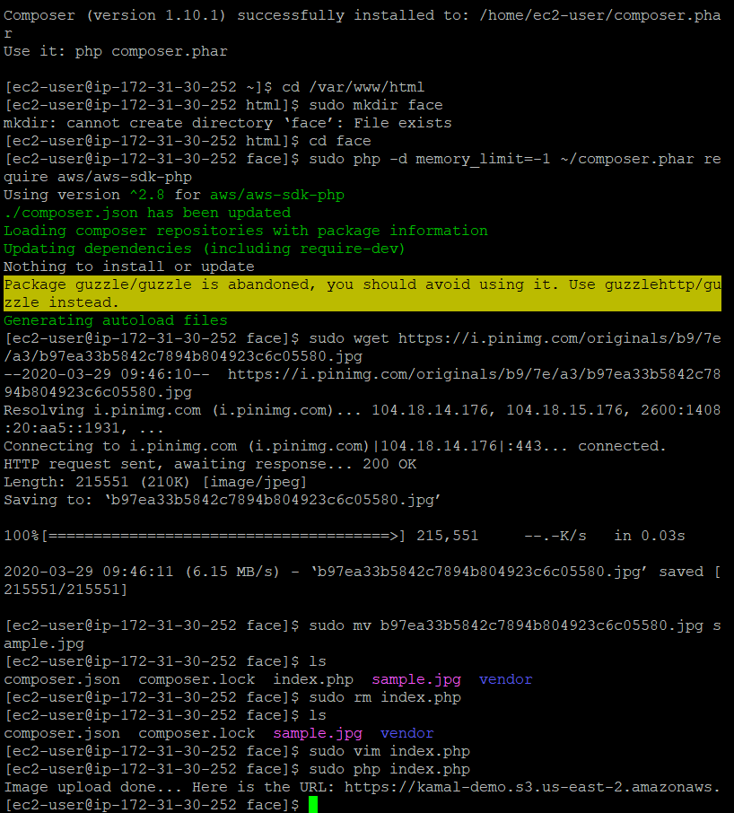

**Screenshots of EC2 & Rekognition:**

**Face Detect success screenshot**

